Computational Drug Discovery Using PCA and K-Means Clustering

BioGrademy Project Report

Student Name: Harminder Kaur

Course Title
Artificial Intelligence in Biotechnology and Healthcare

Project Title
Computational Drug Discovery Using PCA and K-Means Clustering
Introduction
Artificial Intelligence (AI) has become one of the most transformative technologies in modern biotechnology and healthcare. In pharmaceutical industries, AI techniques are increasingly used to accelerate drug discovery, improve molecular analysis, reduce laboratory costs, and assist researchers in identifying promising therapeutic compounds.
Traditional drug discovery methods are highly time-consuming, expensive, and require extensive laboratory experimentation. Researchers often analyze thousands of chemical compounds before identifying a small number of potentially useful drug molecules. Machine learning techniques provide an efficient alternative by processing large biological datasets and identifying hidden patterns among molecular structures.
This project focuses on computational drug discovery using machine learning approaches such as Principal Component Analysis (PCA) and K-Means Clustering. PCA is a dimensionality reduction technique that simplifies high-dimensional molecular datasets while preserving important information. K-Means clustering groups similar compounds together based on molecular characteristics and descriptors.
The combination of PCA and clustering techniques allows researchers to visualize molecular similarities and identify relationships among drug compounds. Such approaches are widely used in pharmaceutical research, biomarker discovery, precision medicine, and toxicity prediction.
In this project, a Kaggle-based molecular dataset was analyzed using Python libraries including Pandas, Scikit-learn, and Matplotlib. The results demonstrate how AI-driven methods can support biotechnology and drug discovery research through data-driven analysis.
Code Section
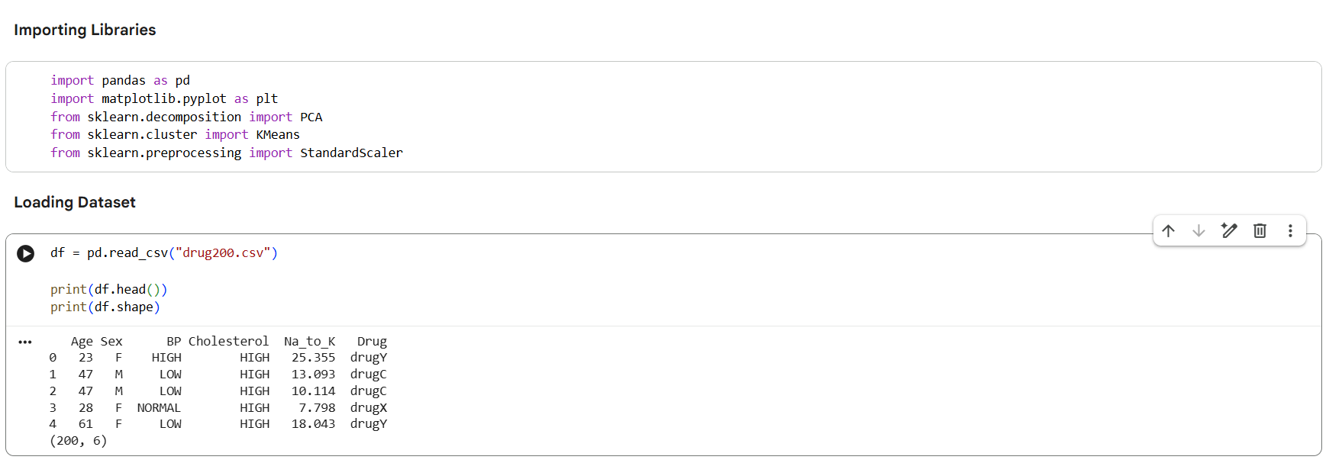
Figure 1: Importing Required Python Libraries and Loading and Previewing the Molecular Dataset
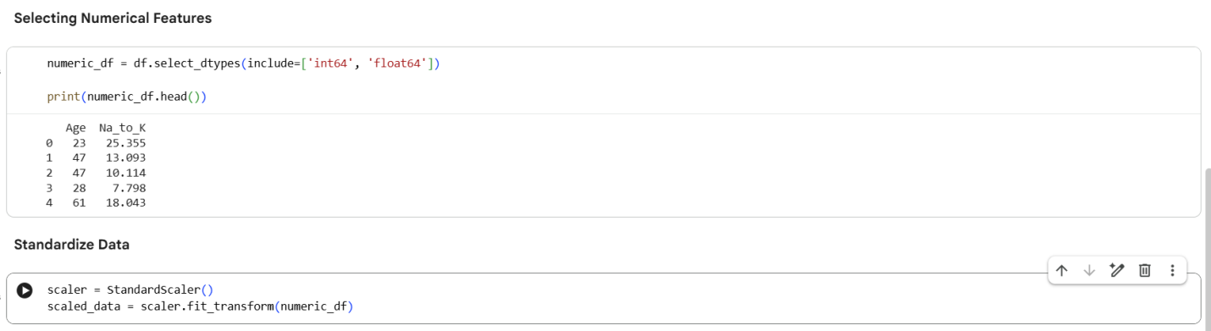
Figure 2: Selection of Numerical Features for Machine Learning Analysis and Data Standardization Using StandardScaler
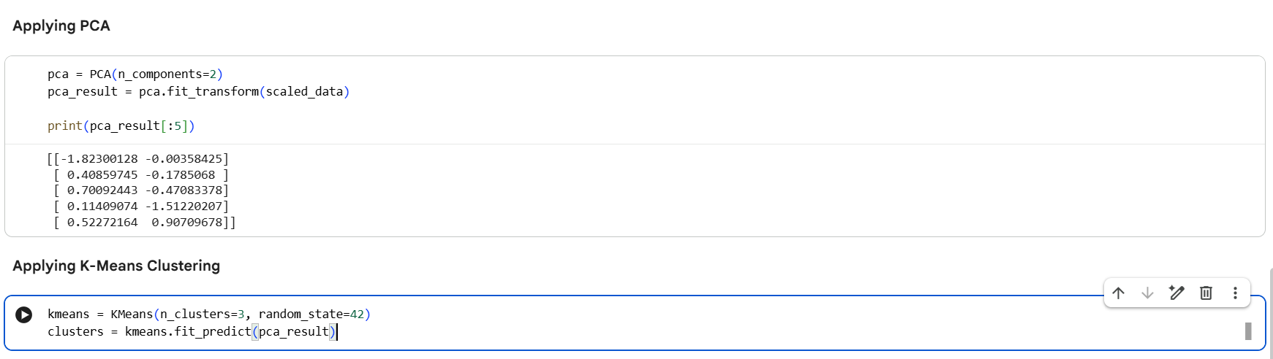
Figure 3: Application of Principal Component Analysis (PCA) and K-Means Clustering Algorithm
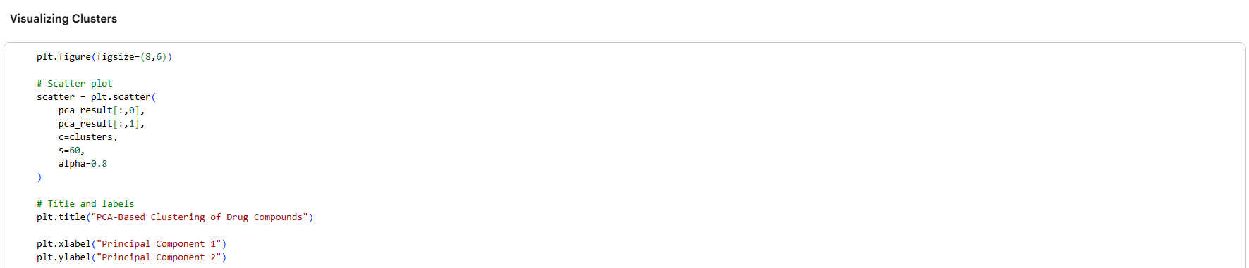
Figure 4: Visualization Code for PCA-Based Drug Compound Clustering

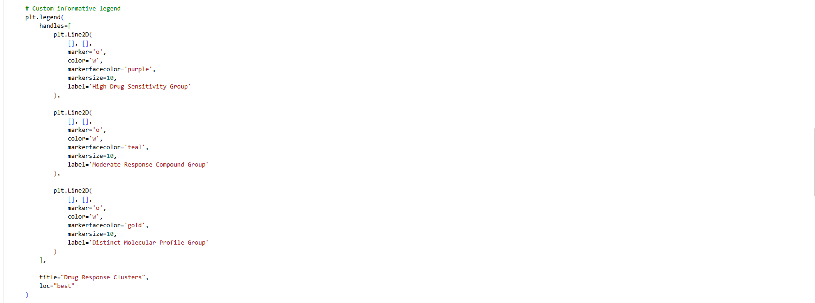
Figure 5: Custom Legend Creation for Drug Response Cluster Interpretation
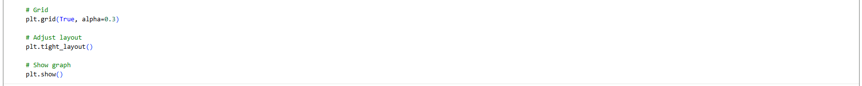
Figure 6: Final Graph Formatting and Visualization Output

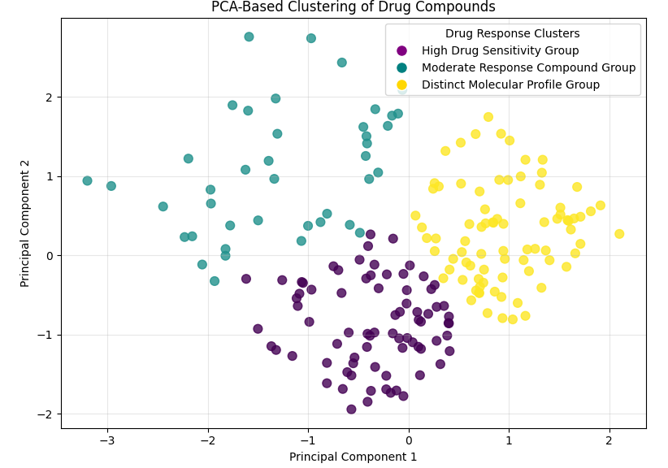
Figure 7: PCA-Based Clustering Visualization of Drug Compounds

Outcome
The machine learning algorithms successfully analyzed the molecular dataset and grouped similar compounds into clusters.

Principal Component Analysis (PCA) Results
The molecular dataset initially contained multiple numerical features representing different chemical descriptors of compounds. Principal Component Analysis (PCA) was applied to reduce the dimensionality of the dataset while preserving important variance present in the data.
After PCA transformation:
- The dataset was reduced to two principal components.
- The transformed data enabled effective two-dimensional visualization.
- PCA simplified the complexity of the molecular dataset without significant information loss.
The PCA scatter plot demonstrated that compounds with similar molecular properties were positioned closer together in the reduced feature space.

K-Means Clustering Results
K-Means clustering was applied to group molecular compounds based on similarity patterns identified within the dataset.
The clustering algorithm successfully:
- Divided compounds into multiple distinct clusters.
- Identified groups of compounds sharing similar molecular characteristics.
- Improved visualization and interpretation of compound relationships.
Different colors in the clustering visualization represented different compound groups generated by the algorithm.

Project Outcome
The project demonstrated that AI and machine learning methods can support drug discovery by identifying patterns among molecular compounds efficiently.

Summary
This project demonstrated the use of Artificial Intelligence in drug discovery using machine learning techniques such as PCA and K-Means clustering. The results showed that clustering methods can identify patterns among molecular compounds and support faster drug analysis.
AI-based drug discovery approaches can contribute to pharmaceutical research, biomarker identification, and personalized medicine.

